CSC 403 ICE 7 Name

Note: this is the handout from class – for your reference.

You only need to answer questions 1 & 2 on this page for this ICE assignment.

1. Choose two substantive lecture content questions (by anyone) – one before and one after the break. State the question and answer in your own words.

a)

b)

1. Trace BFS and DFS starting at node 2 on the graphs given. Label each vertex by the order in which it was visited. Also highlight the edges that were used as part of the traversal.

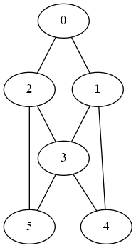BFS DFS

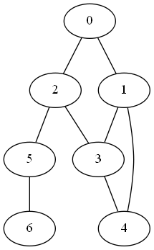

*count self-loops*

*compute the degree of* v

public static int degree(Graph G, int v)

{

}

*compute maximum degree*

public static int maxDegree(Graph G)

{

}

*compute average degree*

public static double averageDegree(Graph G)

{

}

*count self-loops*

public static int numberOfSelfLoops(Graph G)

{

// each edge counted twice